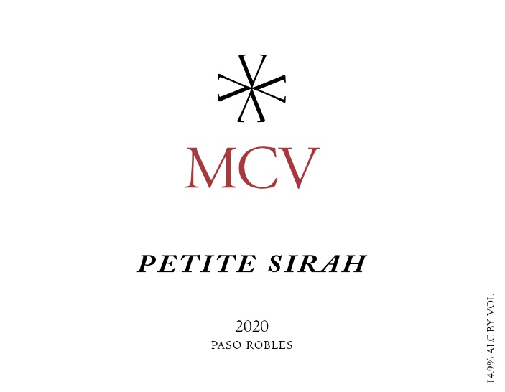

Season: 2020 was an interesting year. The weather was cool and mild through the end of Summer with a normal amount of rain. However, towards the end of the season record breaking heatwaves struck one after the other for the majority of the harvesting time. The resulting wines are big and rich and display some fascinating Terroir that will mark the 2020 vintage. Overall a great year.
Vineyards: Derby Estate Vineyard
Gemeny Vineyard
Parrish Family Templeton
Vinification: Grapes were processed on the same day they arrived at the winery. Sorting table juice was discarded. Post destemmer juice was used for the Rosé. Extra juice was removed as Saignée. Lot was fermented in 2 ton macrobins. Multiple yeasts were used. Lots were cold soaked for 4 days. Fermentation took an average of 12 days. High press was separated out into 3 cuttings.
Aging: This wine was aged in a variety of barrels. All oak was French with around 50% new. Wine was aged 15 months in barrel.
Bottling: It was bottled on 2/14/2022
Technical Information:
Cases Produced: 102
Alcohol: 14.9%
Residual Sugar: 0.05 g/L
pH: 3.71
Total Acid: 6.1 g/L
Volatile Acidity: 0.038 g aa/100mL
Winemaker Notes and Tasting:
This is a fantastic Petite Sirah to enjoy with your Entrée. It will pair with a wide variety of meats and vegetarian dishes.
Aromas of Blueberry, Granite, Dark Chocolate, Smoked Meat and Coffee Grounds
Flavors of Fresh Blueberry, White Pepper, Wet Stone, Chocolate and Drip Coffee
Accolades:
93 pts & Editor’s Choice – The Wine Enthusiast, 11/1/2022

