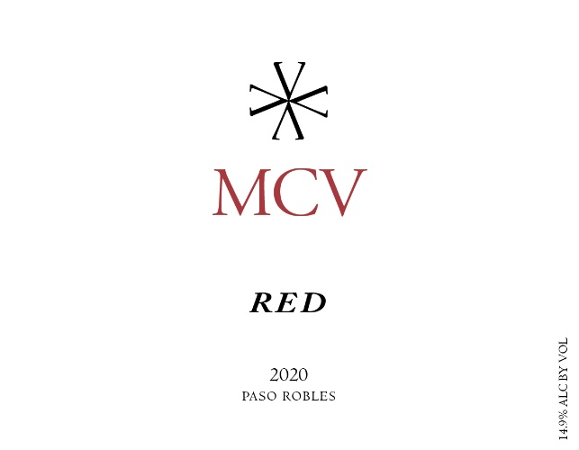

Season: 2020 was an interesting year. The weather was cool and mild through the end of Summer with a normal amount of rain. However, towards the end of the season record breaking heatwaves struck one after the other for the majority of the harvesting time. The resulting wines are big and rich and display some fascinating Terroir that will mark the 2020 vintage. Overall a great year.
Harvest: There were 8 lots of grapes which were harvested from 9/15 – 10/17 with Brix ranging from 24.1° - 28.7°.
Vinification: Grapes were processed on the same day they arrived at the winery. Sorting table juice was discarded. Post de-stemmer juice was used for the Rosé. Lots were fermented in 2 ton macrobins. A variety of yeasts were used, including some wild fermentations. Lots were cold soaked between 3 -7 days. Fermentation took an average of 12 days. Some lots received extended maceration. Some lots were pressed directly into barrel and some into tank to settle. High press was separated out.
Aging: The wine was aged in oak barrels for 15 months.
Bottling: This wine was bottled on 2/15/2022
Technical Information: Blend of Petite Sirah, Syrah, Grenache, Tannat, Vacaresse, Malbec, Mourvèdre & Petit Verdot
712 cases produced
Alcohol: 14.9%
Residual Sugar: 0.05 g/L
pH: 3.8
Total Acid: 5.3 g/L
Volatile Acidity: 0.065 g aa/100mL
Winemaker Notes and Tasting: This is a fantastic everyday wine. It pairs with a wide variety of foods and is great all by itself.
Aromas of Blackberry, Blueberry, Vanilla, Cedar Smoke, Granite, and Mocha
Flavors of Blueberry, Dark Chocolate, Cedar Smoke, Graphite, Black Coffee and Pink Peppercorn
Suggested pairings: Grilled New York with sautéed mushrooms. Stuffed portabella mushrooms. Pasta Carbonara. Pork chops coated with coffee and rosemary. Herb crusted lamb chops.
Accolades:

