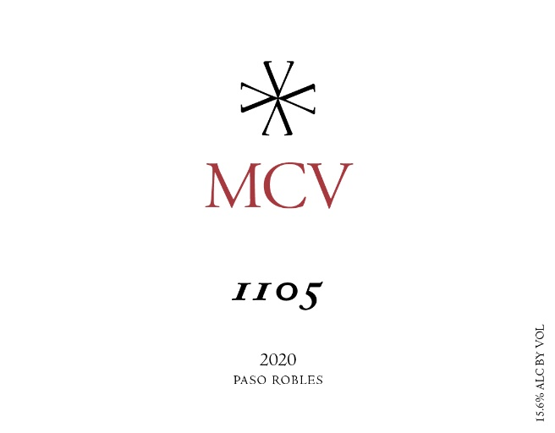
The 1105 is the flagship of MCV. And MCV is the owner and winemaker’s initials, Matthew Christopher Villard. 1105 comes from a play on MCV, which in Roman Numerals is 1,105 so it’s Matt’s name twice since this wine is his expression of the vintage and varietals that make MCV each year.
Season: 2020 was an interesting year. The weather was cool and mild through the end of Summer with a normal amount of rain. However, towards the end of the season record breaking heatwaves struck one after the other for the majority of the harvesting time. The resulting wines are big and rich and display some fascinating Terroir that will mark the 2020 vintage. Overall a great year.
Harvest: There were 5 lots harvested from 9/16 – 10/10.
Vineyards: Rosewynn Vineyard – Petite Sirah
Gemeny Vineyard – Petite Sirah
Glenrose Vineyards – Tannat, Syrah and Grenache
Parrish Family Templeton – Petit Verdot
Vinification: Grapes were processed on the same day they arrived at the winery. Sorting table juice was discarded. Post destemmer juice was used for the Rosé. Lots were fermented in 2 ton macrobins. A variety of yeasts were used, including some wild fermentations. Lots were cold soaked between 3 -7 days. Fermentation took an average of 12 days. Some lots received extended maceration. Some lots were pressed directly into barrel and some into tank to settle.
Aging: The wine was aged in oak for 15 months, blended and returned to barrel for 4 more months. It was 100% French with around 67% being new. It was a combination of 225L Barriques and 500L Puncheons.
Bottling: It was bottled on 5/8/2022
Technical Information:
Blend: 61% Petite Sirah, 14% Tannat, 9% Petit Verdot, 8% Syrah, 7% Grenache, 1% Viognier
Cases produced: 164
Alcohol: 15.6%
Residual Sugar: 0.04 g/L GF
pH: 3.71
Total Acid: 6.02 g/L
Volatile Acidity: 0.056 g aa/100mL
Winemaker Notes and Tasting:
This is an elegant, balanced, rich wine that should age for up to 15 years.
Aromas of Violet, Dark Chocolate, Cassis, Tobacco, Wintergreen and Roasted Coffee
Flavors of Blackberry, Blueberry, Granite, Licorice, Violet and Cocoa Nib
Accolades:
93 pts – The Wine Enthusiast

