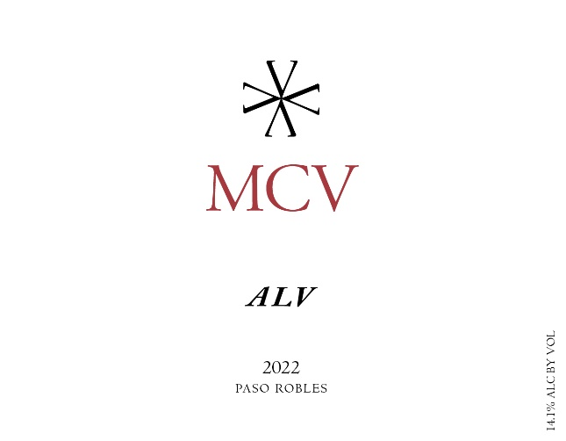

Season: 2022 was a year that most winemakers will remember for a long time. A late deep freeze early in the season and a multi-record breaking heatwave at the beginning of harvest contributed to what will hopefully be a once in a lifetime vintage.
Harvest: The grapes were harvested on 9/8
Vineyards:
ONX Briarwood Estate 530 Clone
Vinification: The juice was pressed and settled overnight and clean racked to barrels and stainless-steel drums and inoculated. The vessels were kept in the cold barrel room for the entirety of fermentation. No secondary fermentation.
Aging: Aged sur lees in Oak Barrels and Stainless Steel containers for 2 months.
Bottling: This wine was bottled on 2/9/23

Technical Information: 100% Sauvignon Blanc
cases produced: 69
Alcohol: 14.1%
Residual Sugar: 0.08g / 100mL
pH: 3.31
Total Acid: 5.6g tar / 1L
Volatile Acidity: 0.032g aa / 100mL
Winemaker Notes and Tasting: This is a bright, and extremely aromatic wine. Named after the winemaker’s sister, this wine is perfect for drinking now.
Aromas of Mango, Papaya, Lime and Wet Stone
Flavors of Mango, Papaya, Crushed Stone and Keyur Lime.
Accolades:

